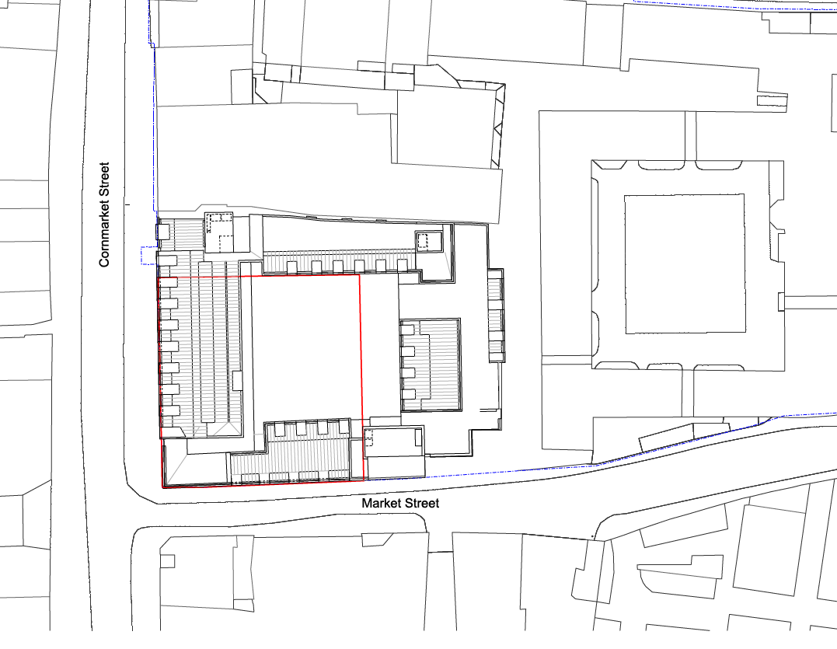
Appendix 1 - 20/01468/FUL – Site Plan

